Lay The Draw Strategy
Last updated: 22/07/25
Next update due: 22/10/25 (mark in calendar)
Aim:
To bet on the Lay side of the Draw market of football matches profitably. Therefore, I am looking for events that are less likely to draw.
Objectives:
- Event selection:
  - Research and select leagues that are proven to draw less frequently. Filter out high drawing leagues.
  - Find statistics that have a correlation to a Home or Away win, then optimise and back test.
- Entry and exits.
- Decide on a staking strategy.
  - Take into consideration risk/reward.
  - Bankroll management. (Maximum liability, stake amount)
- Re-evaluate strategy at set intervals.
- Future considerations.
Event Selection:
Research and select leagues: Using the data collected, find if events have won or drawn and group data by leagues. The win or drawn columns must be summed up to give a strike rate. Columns must include League, Games Played, Won, Drawn, Strike.
This will give an indication on which leagues will naturally draw less frequently. The poor performing leagues are to be filtered by strike rate more than 76% and must have at least 10 events in the data base.
This will produce a list of leagues to use for strategy optimisation. The purpose of this is to gain initial confidence in the strategy.
Find correlated statistics: Test different statistics to find any correlation that improves performance.
Training data set: 60% of data
Optimise strategy: Using the list of filtered leagues, research statistics that correlate to less draws. Now use the Training data set and programmatically optimise a range for the chosen statistics. Choose the best performing strategy and display via a PnL graph.
To counter overfitting, any paired statistics, such as ‘< xyz and > xyz’ should be matched. Having one value higher or lower than the other will produce overfit results.
Randomise data: The entire data set order should then be randomised, split into 60% and re-test the chosen strategy. Repeat 100 times and display on PnL graph.
This will produce another list of leagues and their win/draw strike rate. Compare with the original list. Some leagues may not be suitable for this strategy and the league list should be filtered further.
The graph produced should neither look like a straight line up diagonally (probably overfit results) or a ranging, choppy line (unprofitable strategy).
The randomised results should somewhat mirror the original data PnL.
Reverse strategy: Now use the opposite criteria for the strategy and re-test on the Training data set. The theory is that this should produce negative or less desirable results compared to the original data set.
Validate strategy: If all results are positive from the above test, then finally validate the strategy.
Validating data set: 40% of data.
Now with the strategy filtered league list, test the strategy with the Validating data set. If it still produces a positive result, then the strategy can be confidently forward tested with a live or paper account.
Note: Any adjustments to the strategy must only be made to the Training data set. Validating the strategy must only be done once, and once a strategy has been decided on. Any further adjustments should only be made at the decided-on update interval, or a completely new strategy must be used.
Entry and Exit’s.
Eligible Leagues:
Set and forget: Using the AutoTrader tool, assign events the Lay the Draw strategy that meet the requirements. Then place a lay bet no later than 5 minutes before kick-off. This is to give enough time for the bet to be matched and readjust if required.
The bet will then be left to run to full time. Resulting in maximum profits or losses.
Staking strategy.
Risk/Reward: The average price required are odds of 4.0. Givig a R/R ratio of 3/1. Therefore, a strike rate of above 75% is required to be profitable. It is essential to place bets below 4.0 at every opportunity to keep the average price below 4.0.
Maximum liability: This should be kept at an average of 4.0 or below. The price should be monitored continuously when available and an entry made if the price falls below a given amount.
Stake amount: A percentage-based stake should be used at a base rate of 1% of bank roll. This should be updated weekly. The full stake is to be placed at the time stated in the Entry and Exit’s section.
Re-evaluate Strategy:
Interval: Every 3 months or end of every quarter.
Q1: March, Q2: June, Q3: September, Q4: December
This document should be reviewed and any alterations made in a new version. Changes should be made after any findings that will improve the performance of the strategy.

Future Considerations:
These are theories or ideas that are yet untested but should be used to improve the strategy’s performance after live testing.
- Confidence staking. During an event, if the favourite team is winning by half time by 2 points, is it reasonable to assume they will then go on the win the match? If so, then a further lay bet can be placed on the draw market. The liability will be much higher but if this second stake proves to have a high strike rate, then it will reduce the risk/reward ratio from around 3/1 to 2/1. Gather evidence that this will produce higher returns.
- High performing league staking. Some leagues will greatly out-perform others. The leagues with a good track record could have a higher base stake rate of 2%, yielding higher returns. Pick the top 3-5 leagues for higher staking. Gather evidence that this will produce higher returns.

Strategy Test – Q1 + Q2 2025
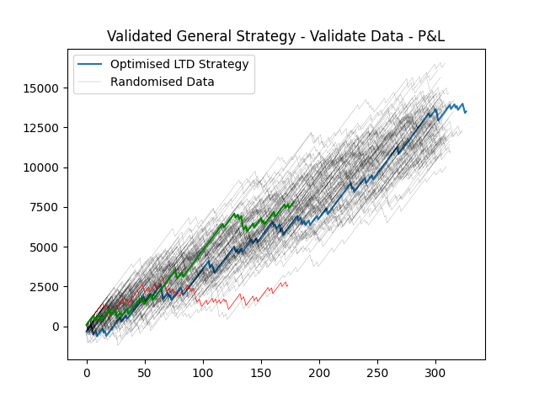

hva | goal_edge | draw_perc | total_matches | win | draw | avg_draw_price | profit | loss | pnl
-7 | -5 | 0.143731 | 327 | 280 | 47 | 3.964043 | 27440 | 13931.0 | 13509.0

Results of live testing analysis – Q1 + Q2
Try to explain what you have found.
What was the analysis from the strategy used? PnL, Win Rate, Avg Win/Loss etc… average price over time (weekly) and how this effects pnl or win rate.
Was there anything you found that was unexpected that may improve the system?
I.E. now a win rate has been established, a more accurate risk/reward ratio can be applied. Using this strategy, or indeed any sports betting strategy, all that really matters is the odds or price you enter the market. It is yet unconfirmed if the stats used for the strategy have any correlation with the price used. As football results can appear random the odds reflect the results, no match will come in just because you want it to. Which seems self-explanatory but when you want something to happen it feels wrong when it doesn’t. Therefore, I theorise that a lower average price must be achieved to produce a long term positive expected value (+EV). I think that from the results of Q1 + 2, albeit fragmented, it shows that a lower price entered on the lay side over time results in +EV. This could be proof of edge this season without the need to risk unbalanced amounts when the bet is in my favour.

